Mulesoft Anypoint Platform
Experiment 8
Create a Mule project to update and delete records from the MySQL table using Database operations.
Solution:
This experiment enhances the database integration by adding UPDATE and DELETE functionality using Mule’s Database connector.
Steps:
- Continue in your existing Mule project.
- For Update, drag an HTTP Listener:
  - Path: /updatestudent
  - Keep the same config as the previous flows.
- Drag a Database - Update component:
  - For the config keep the database global config.
  - For the SQL query:
- UPDATE student2 SET sname = :sname WHERE sno = :sno
  - Keep the input parameters;
- 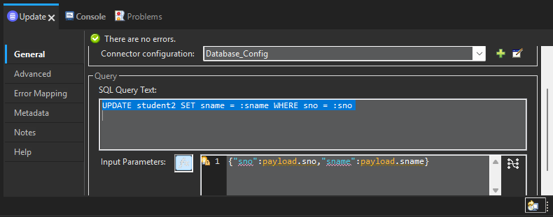
- Drag a transform message component with the json message “updated successfully”.
- The final flow will be :
- 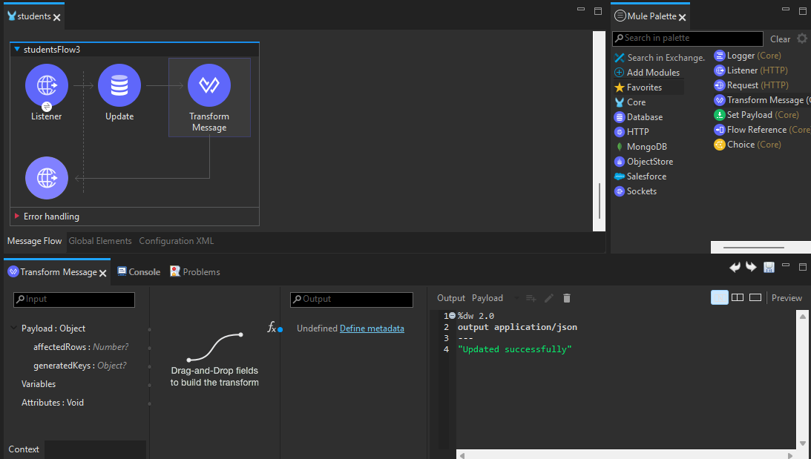
- Save the flow.
- For Delete, drag another HTTP Listener:
  - Path: /deletestudent
  - Keep the same config as the previous flows.
- Drag a Database - Delete component:
  - For the database config as the previous flows.
  - Keep the sql query like this:
  - DELETE FROM student2 WHERE sno = :sno
  - Keep the input parameters:
  - 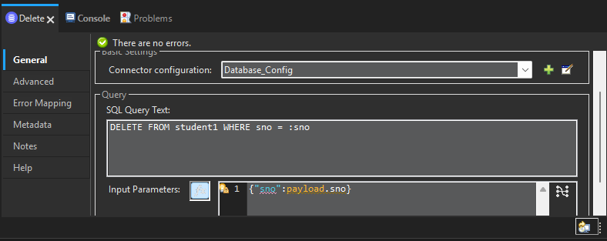
- Drag the transform message component and keep the message as data deleted successfully.
- The final flow will look like this:
- 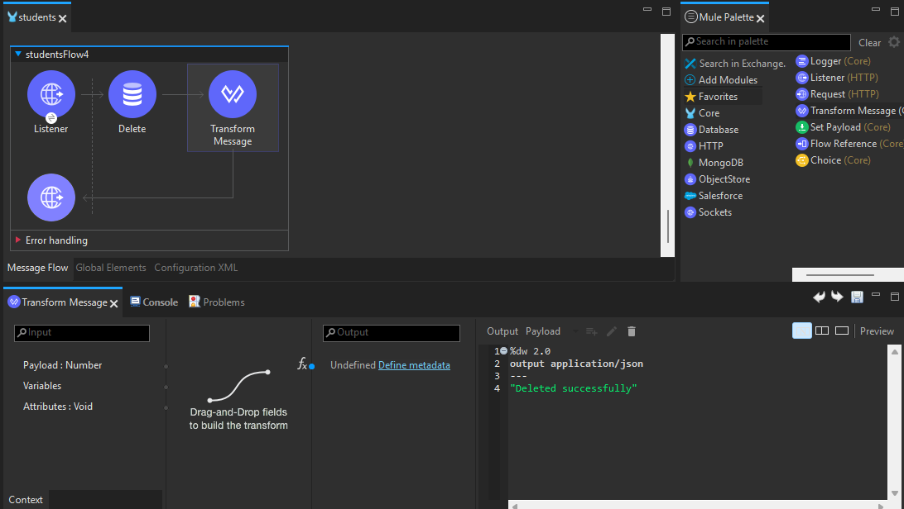

- Save the file and run the project.
- Go to postman and check if both the flows are executing correctly:
- For update flow the output will be :
- 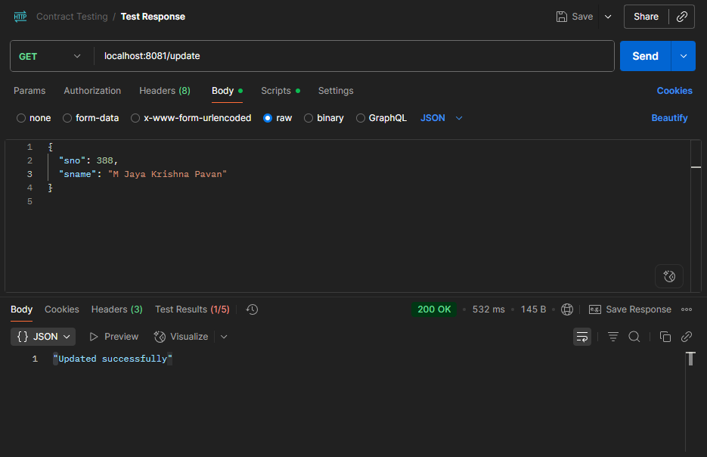
- For delete the output will be like this:
- 